**VISVESVARAYA TECHNOLOGICAL UNIVERSITY**

**BELAGAVI, KARNATAKA**



A Mini Project Report

**(Fifth Semester)**

On

**“Ecart (E-Market Web)”**

Submitted in the partial fulfillment for the requirements for

the conferment of degreeof

**BACHELOR OF ENGINEERING**

In

**INFORMATION SCIENCE AND ENGINEERING**

By

**Mr. PRAJWAL R USN: 1BY18IS084**

**Ms. RASHMI B S USN: 1BY18IS098**

Under the guidance of

**Mrs. DRAKSHAVENI G**

**Asst. Professor**



**2020-2021**

## BMS INSTITUTE OF TECHNOLOGY & MANAGEMENT YELAHANKA, BANGALORE - 560064

**DEPARTMENT OF INFORMATION SCIENCE & ENGINEERING**



**CERTIFICATE**

This is to certify that the Mini Project (Fifth Semester) entitled **“Ecart (E-Market Web)”** is a Bonafede work carried out by **Mr. Prajwal R (1BY18IS084), Ms. Rashmi B S (1BY18IS098)** in partial fulfillment for the award of **Bachelor of Engineering Degree in Information Science and Engineering** of the Visvesvaraya Technological University, Belagavi during the year 2020-21. It is certified that all corrections/suggestions indicated for Internal Assessment have been incorporated in this report. The mini project report has been approved as it satisfies the academic requirements with respect to mini project work for the B.E Degree.

### Signature of the Guide Signature of the HOD

Mrs. Drakshaveni G Dr. Pushpa S K

**Name of the Examiners Signature with Date**

**1.**

**2**.

## ACKNOWLEDGEMENT

We are happy to present this mini project after completing it successfully. This mini project would not have been possible without the guidance, assistance and suggestions of many individuals. We would like to express our deep sense of gratitude and indebtedness to each and every one who has helped us make this project a success.

We are grateful to **Dr. Mohan Babu G.N,** Principal, BMS Institute of Technology & Managementfor his constant encouragement and inspiration in taking up this project.

We heartily thank **Dr. Pushpa S K,** Head of Department, Information Science and Engineering, for her constant encouragement and inspiration in taking up this project.

We sincerely thank **Dr. Manjunath T N**, Professor, Dept. of Information Science and Engineering and Dean (External Relations) for his constant support and motivation.

We gratefully thank our Project guide, **Mrs. Drakshaveni G,** Associate Professor,for her encouragement and advice throughout the course of the Project work.

Special thanks to all the staff members of the Information Science Department for their help and kind cooperation. We also thank our parents and friends for their unconditional love and encouragement and support given to us in order to finish this precious work. Last but not the least we would like to thank God for giving us the strength and motivation through the course of this Project.

By,

PRAJWAL R

RASHMI B S

# DECLARATION

We, hereby declare that the Mini Project titled “ECART (E-MARKET WEB)” is a record of original Mini Project work undertaken for the award of the degree of Bachelor of Engineering in Information Science and Engineering of the Visvesvaraya Technological University, Belagavi during the year 2020-21. We have completed this Mini Project work under the guidance of **Mrs. Drakshaveni,** Assistant professor, Dept. of MCA.

We also declare that this Mini Project report has not been submitted for the award of any degree, diploma, fellowship or other title anywhere else.

 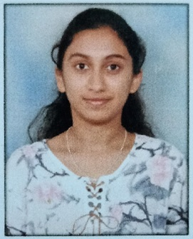

PRAJWAL R RASHMI B S

## ABSTRACT

In this era of internet, e-commerce is growing by leaps and bounds keeping the growth of brick-and-mortar businesses in the dust. In many cases, brick-and-mortar businesses are resorting to having a counterpart which is internet or e-commerce driven. People in the developed world and a growing number of people in the developing world now use e-commerce websites on a daily basis to make their everyday purchases. Still the proliferation of e-commerce in the under-developed world is not that great and there is a lot to desire for. This paper outlines different aspects of developing an e-commerce website and the optimum solution to the challenges involved in developing one. It consists of the planning process, which starts with determining the use case, domain modeling and architectural pattern of the web application. The entire development process is primarily divided into two parts: the front-end development and the back end development. This no-nonsense method of developing an e-commerce website can be easily replicated and followed in developing e-commerce websites in the developing and under-developed countries where computing resources are scarce and expensive because of their socio-economic condition.

**TABLE OF CONTENTS**

* **Chapter 1 Introduction**

1.1 Outline 1

1.2 Motivation and scope 1

1.3 Problem Statement 1

1.4 Limitations 1

* **Chapter 2 Requirement Specification**

2.1 Functional Requirements 2

2.2 Non-Functional Requirements 3

2.3 Domain Constraints 4

* **Chapter 3 System and Requirements Analysis**

3.1 Overall System Description 5

3.2 Display Module 6

3.3 Updating Module 6

3.4 Deletion Module 7

* **Chapter 4 System Design**

4.1 Data Flow Diagram 8

* **Chapter 5 Implementation**

5.1 Description of Database Used (Backend) 10

5.2 Description of Implementation (Frontend) 10

* **Chapter 6 Testing**

6.1 Component Tests 12

6.4 System Tests 14

* **Chapter 7 Interpretation of Results** 15

**Conclusion** 23

**References**  24

**List of Figures/Tables**

* 1. : Overall System Design 5
  2. : Display Process Flow Diagram 6
  3. : Update Process Flow Diagram 6
  4. : Deletion Process Flow Diagram 7
  5. : User collection 8
  6. : Product collection 8
  7. : Order collection 9
  8. : User Registration Module Test 12
  9. : User/Admin Login Module Test 13
  10. : Order Module Test 13
  11. : System/Integration Test 14
  12. : Home Page 15
  13. : Registration Page 15
  14. : Sign-in Screen 16
  15. : Product Screen 16
  16. : Cart Screen 17
  17. : Shipping Screen 17
  18. : Order Screen 18
  19. : User Screen 18
  20. : Admin monitoring order 19
  21. : Admin monitoring product 19
  22. : Create product 20
  23. : Database 20
  24. : Users collection 21
  25. : Orders collection 21
  26. : Products collection 22

**CHAPTER 1**

**INTRODUCTION**

* 1. **Outline**

E-Commerce (Electronic Commerce) is a process of doing business through computer networks. The primary goal of an e-commerce site is to sell goods and services online. Online Shopping System helps in buying goods, products and services online by choosing the listed products from E-Commerce sites. User can login into an e-commerce website, once he logged in then automatically one shopping cart will be created, once the user selects an item it will add to cart. In case the user thinks the selected item is not useful, then he/she can delete that item from the cart. The basic concept of the application is to allow the customer to shop virtually using the Internet and allow customers to buy the items of their desire from the store. E-commerce is fast gaining ground as an accepted and used business paradigm.

### Motivation and scope

In day-to-day life, people are more enthusiastic to buy products where they are rushing towards malls and shops. It requires lots of time to travel to the particular shop to buy the goods. It is having lots of manual work. Since everyone is leading busy lives now-a-days, time means a lot to everyone. Also, there are expenses for travelling from house to shop. It is less user-friendly. In the current system users must go to shop and order products. Moreover, the shop from where we would like to buy may not be open 24*7*365. Hence, we have to adjust our time with the shopkeeper’s time or vendor’s time. In the current e-commerce system users have to go shop to view the description of the product. To overcome these difficulties, an e-commerce system plays a vital role.

### Problem Statement

Design and develop User Interface for E-commerce site, where people can buy their desired products of their choice. Admin can edit the details of the products, view the ordered details.

### Limitations

* It requires the NODE JS to be installed without which it will not be able to function.
* The project currently runs on a locally hosted server; hence it cannot reflect the changes.
* It cannot dynamically update the registrations and needs to be done by the Database administrator.

## CHAPTER 2

**REQUIREMENT SPECIFICATION**

### Functional Requirements

**Request for Login**

The system shall require a user to register, in order to carry out any orders with it. It will ask the user for the following information like user name, password, etc. If correct, the system allows the user to carry out further operations. While registering for the first time, a user should enter an email id which is not present in the database.

**User Profile Updating**

A user can update their profile like changing name and can also change their password in the account settings session.

**Admin login**

Admin can login and edit the details like adding new products for users, also delete or update the information. Admin can have access to ordered details of different users.

**Web Browser**

A Web Browser is a software application for accessing information on the World Wide Web. Each individual web page, image, and video is identified by the distinct URL, enabling browsers to retrieve and display them on the user’s device.

**Node js**

Node.js is an open source, cross-platform runtime environment for developing server-side and networking applications. Node.js applications are written in JavaScript, and can be run within the Node.js runtime on OS X, Microsoft Windows, and Linux. Node.js also provides a rich library of various JavaScript modules which simplifies the development of web applications using Node.js to a great extent.

### Non-functional Requirements

**Performance**

Response time of the System should be less than 3 second most of the time. Response time refers to the waiting time while the system accesses, queries and retrieves the information from the databases (DB-user, DB-schedule etc).

**Reliability**

* It shall be available 24 hours a day, 7 days a week.
* It shall always provide accurate status of the registered complaints.
* This software shall be robust enough to have a high degree of fault tolerance.

For example, if the user enters a wrong password, the system should not crash and shall identify the invalid input and produce a suitable error message.

* The application shall be able to recover from power failures and other natural catastrophes and rollback the databases to their most recent valid state.

**Usability**

It shall provide an easy-to-use graphical interface similar to other existing registration systems so that the users do not have to learn a new style of interaction. Any notification or error messages generated by the website shall be clear, succinct and polite.

**Integrity**

Only the system administrator has the right to change system parameters, such as complaint categories, complaint status etc. The system should be secure and must use encryption to protect the databases. Users need to be authenticated before having access to any data.

**Interoperability**

The website shall minimize the effort required to couple it to another system, such as the Course management database system.

### Domain Constraints

* **Regulatory policies:** It is mandatory that no text box must be left empty or contains insufficient data.
* **Hardware limitations:** There must be a 64 MB on board memory.
* **Control functions:** The software must be very user-friendly and display appropriate error messages.
* **Interfaces to other applications**: Not applicable.
* **Parallel operations:** It must support many users simultaneously.
* **Software Requirement:** Operating System- Windows/Mac/Ubuntu

Browser- Chrome/Mozilla Firefox/Internet Explorer

* **Hardware Requirement:** Processor- 32 or 64bit

Memory- 2GB RAM

Hard Disk- 100M

## CHAPTER 3

**SYSTEM/ REQUIREMENT ANALYSIS**

### Overall System Design

User login

Admin login

home

Logged in successfully

Logged in successfully

Option of

performing

any query

Option of

performing

any query

Retrieve

data

Insert Data

Delete data

Data

accessed

**Fig. 3.1: Overall System Design**

This project is about creating a database about e-commerce System. The Ecart facilitates the customers to search their favorite products, order required products, check the price and availability of items, etc. The aim of case study is to design and develop a database maintaining the records of different products, customers, orders. The record of product includes its id, name, image, price, brand, rating, reviews, count in stock, description and category of the product.

The user can login with a login screen where he/she asked to enter his/her Username and Password. If the correct input is received from the user, then user is logged in and can view order history, cart product. Only the Database Administrator has the authority to remove user accounts.

### Display Module

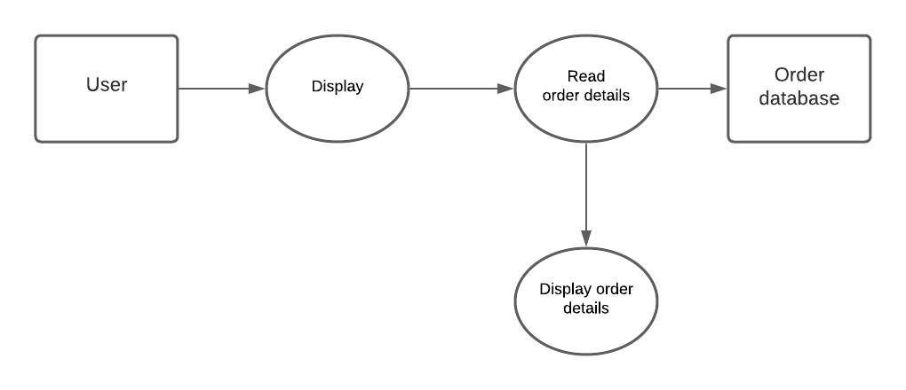

**Fig. 3.2: Display Process Flow Diagram**

This mode is used to view the information about orders. User can view details of their orders.

### Update Module

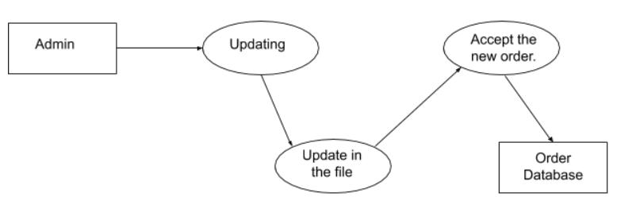

**Fig. 3.3: Update Process Flow Diagram**

There are situations where the details of user or product are mistyped and are stored in the database. To update them we need to use this mode. The product details can be updated only by the admin. User information can be updated by user themself.

### Deletion Module

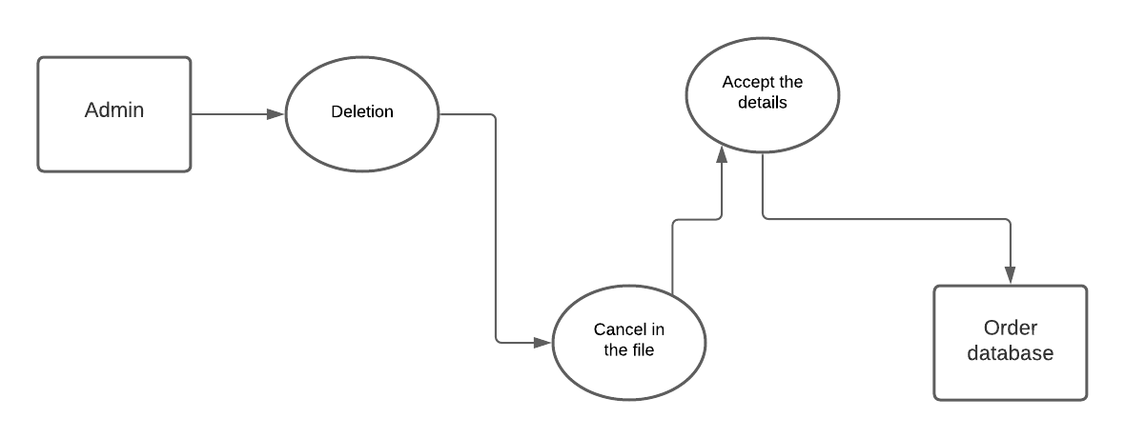

**Fig. 3.4: Deletion Process Flow Diagram**

In Deletion mode the admin has the right to delete order of the users. Admin also has right to delete any products from the site.

## CHAPTER 4

## SYSTEM DESIGN

### Data Flow Diagram

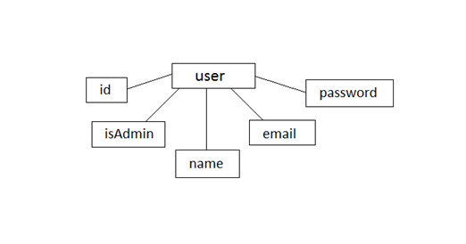

**Fig. 4.1** **user collection**

User collection is used to identify the user. It has id, isAdmin, name, email, password as its attributes. isAdmin is used to differentiate normal user from admin, email id is unique to avoid multiple registration of user.

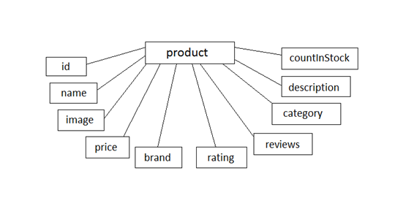

**Fig. 4.2** **product collection**

Product collection is used to store all the products and its details. id is self-generated whereas name, image, price, brand, rating, reviews, category, description, countinstock are attributes entered by admin. If countinstock is 0, then user cannot order the product.

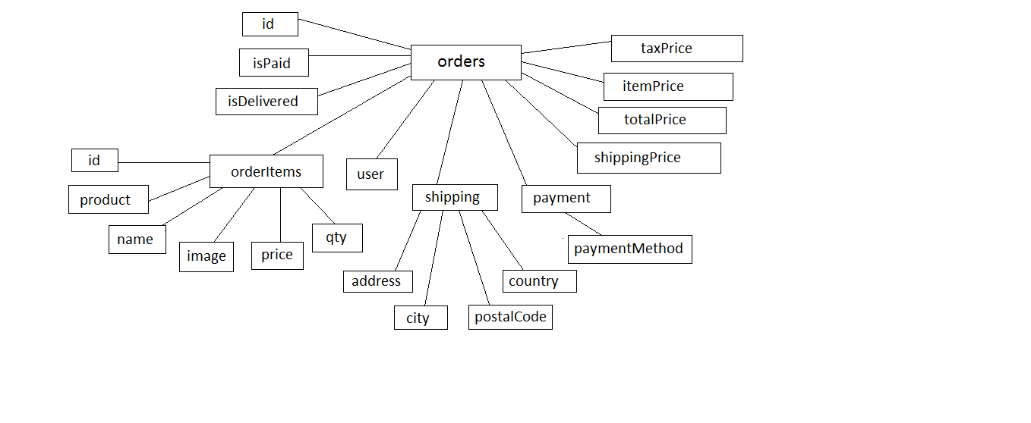

**Fig. 4.3 order collection**

Order collection is the core collection in this project used to store order. id is self-generated by mongo database for each entry. Some of its attributes has further divisions. ispaid is used to verify payment details, isdelivered is used to track delivery of product. Orderitems has order id, product, name, image, price, quantity details. User attribute is to track which user has made order. Shipping attribute is for obtaining shipping address. Payment is to track payment method. Taxprice, itemprice, shippingprice, totalprice are there to track the amount that customer has to pay for order.

**CHAPTER 5**

## IMPLEMENTATION

**5.1 Description of Database Used (Backend)**

**MONGODB:**

Mongo DB is an open-source NoSQL database management program. NoSQL is used as an alternative to traditional relational databases. NoSQL databases are quite useful for working with large sets of distributed data. Mongo DB is a tool that can manage document-oriented information, store or retrieve information. Mongo DB supports various forms of data. It is one of the many non-relational database technologies. Mongo DB is almost 100 times faster than traditional database system.

**5.2 Description of Implementation**

**NODE JS:**

Node.js is a runtime environment that allows software developers to launch both the frontend and backend of web apps using JavaScript. Although JS underpins all the processes for app assembly, as a backend development environment, Node.js, differs from the frontend environment. It has unique APIs that support HTTP requests, file systems and other server-side features for which frontend APIs provide limited support.

**EXPRESS JS FRAMEWORK:**

Express is a small framework that sits on top of Node.js’s web server functionality to simplify its APIs and add helpful new features. It makes it easier to organize your application’s functionality with middle ware and routing. It adds helpful utilities to Node.js’s HTTP objects and also facilitates the rendering of dynamic HTTP objects. Express is a part of full stack JavaScript solution used in building fast, robust, and maintainable production web applications.

**HTML5:**

Hypertext Markup Language revision 5 (HTML5) is markup language for the structure and presentation of World Wide Web contents. HTML5 supports the traditional HTML and XHTML- style syntax and other new features in its markup, New APIs, XHTML and error handling.

### CSS3:

Cascading Style Sheets (CSS). As you probably know, CSS is a style language that describes how HTML markup is presented to the user. CSS3 is the latest version of the CSS specification. CSS3 contains just about everything that’s included in CSS2.1, the previous version of the spec. It also adds new features to help developers solve a number of presentation-related problems without resorting to scripting plugins or extra images.

### JAVASCRIPT:

JavaScript is a programming language that started off simply as a mechanism to add logic and interactivity to an otherwise static Netscape browser. In the system since its introduction, it has not only supplanted a variety of other competing languages and technologies to become the standard for browser-based programming, but it has also expanded beyond the client space to become a dominant language on the server side, as well.

**REACT JS:**

React (also known as ReactJS) is an open-source, front end, JavaScript library for building user interfaces or UI components. It is maintained by Facebook and a community of individual developers and companies. React can be used as a base in the development of single-page or mobile applications. However, React is only concerned with state management and rendering that state to the DOM, so creating React applications usually requires the use of additional libraries for routing. React Router is an example of such a library.

## CHAPTER 6

## TESTING

### Component Tests

### User Registration Module

**Table 6.1 User Registration Module Test**

|  |  |  |
| --- | --- | --- |
| **TEST UNIT** | **TEST CASE** | **RESULT** |
| Registration Screen | Providing an email id which is already present in the database. | The system will not register the user by generating a message saying “Loading...”. |
| Registration Screen | Providing an email id which is not present in the database. | The system redirects user to sign in further. |

**Login Module**

**Table 6.2 User/Admin Login Module Test**

|  |  |  |
| --- | --- | --- |
| **TEST UNIT** | **TEST CASE** | **RESULT** |
| Login Screen | An invalid username or password is entered by the user. | The system generates a message saying “Request failed with status code 401”, whichever is the case. |
| Login Screen | A valid username or password is entered by the user. | The system grants access to the user and takes him to the home page. |

**Order Module**

**Table 6.3 Order Module Test**

|  |  |  |
| --- | --- | --- |
| **TEST UNIT** | **TEST CASE** | **RESULT** |
| Order Window | Selecting users favourite product and order it to proper shipping address, provide different payment method and place the order. | Order will be updated in the database. User is provided with the order summary. |

**6.4 System Test**

**Table 6.4 System/Integration Test**

|  |  |  |
| --- | --- | --- |
| **TEST UNIT** | **TEST CASE** | **RESULT** |
| Sign-in | Click on user/admin sign in button | Opens the sign-in page for whichever the case is. |
| Cart | Click on cart button | Opens a cart page for whichever the case is. |
| Order History | Click on profile name | Displays all the orders made in the account and provides details of the order |
| Manage Order | Click on order under admin button. | Displays the no. of complaints under process, not processed and closed complaints. |
| Manage Product | Click on product under admin | Displays all the products with their details to add/ delete the product, also to modify the given product. |
| Search Category | Click on **≡** button | Opens a side pop-up providing all different categories of product. |
| Change Password | Click on the profile name | Enter new password in password section and select update. |
| Logout | Click on the logout button | Successfully logs out from the website for whichever the case is and opens sign-in page. |

**CHAPTER 7**

**INTERPRETATION OF RESULTS**

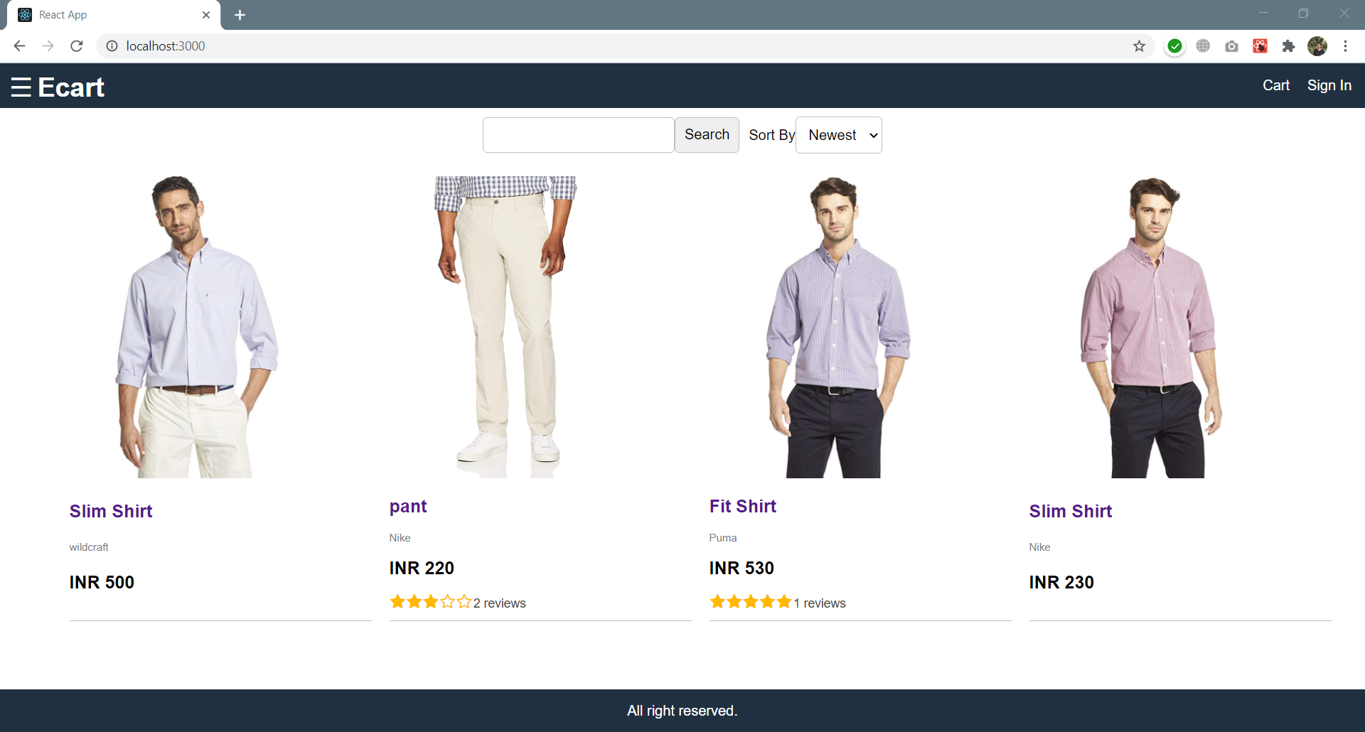

Fig.7.1: Home Page

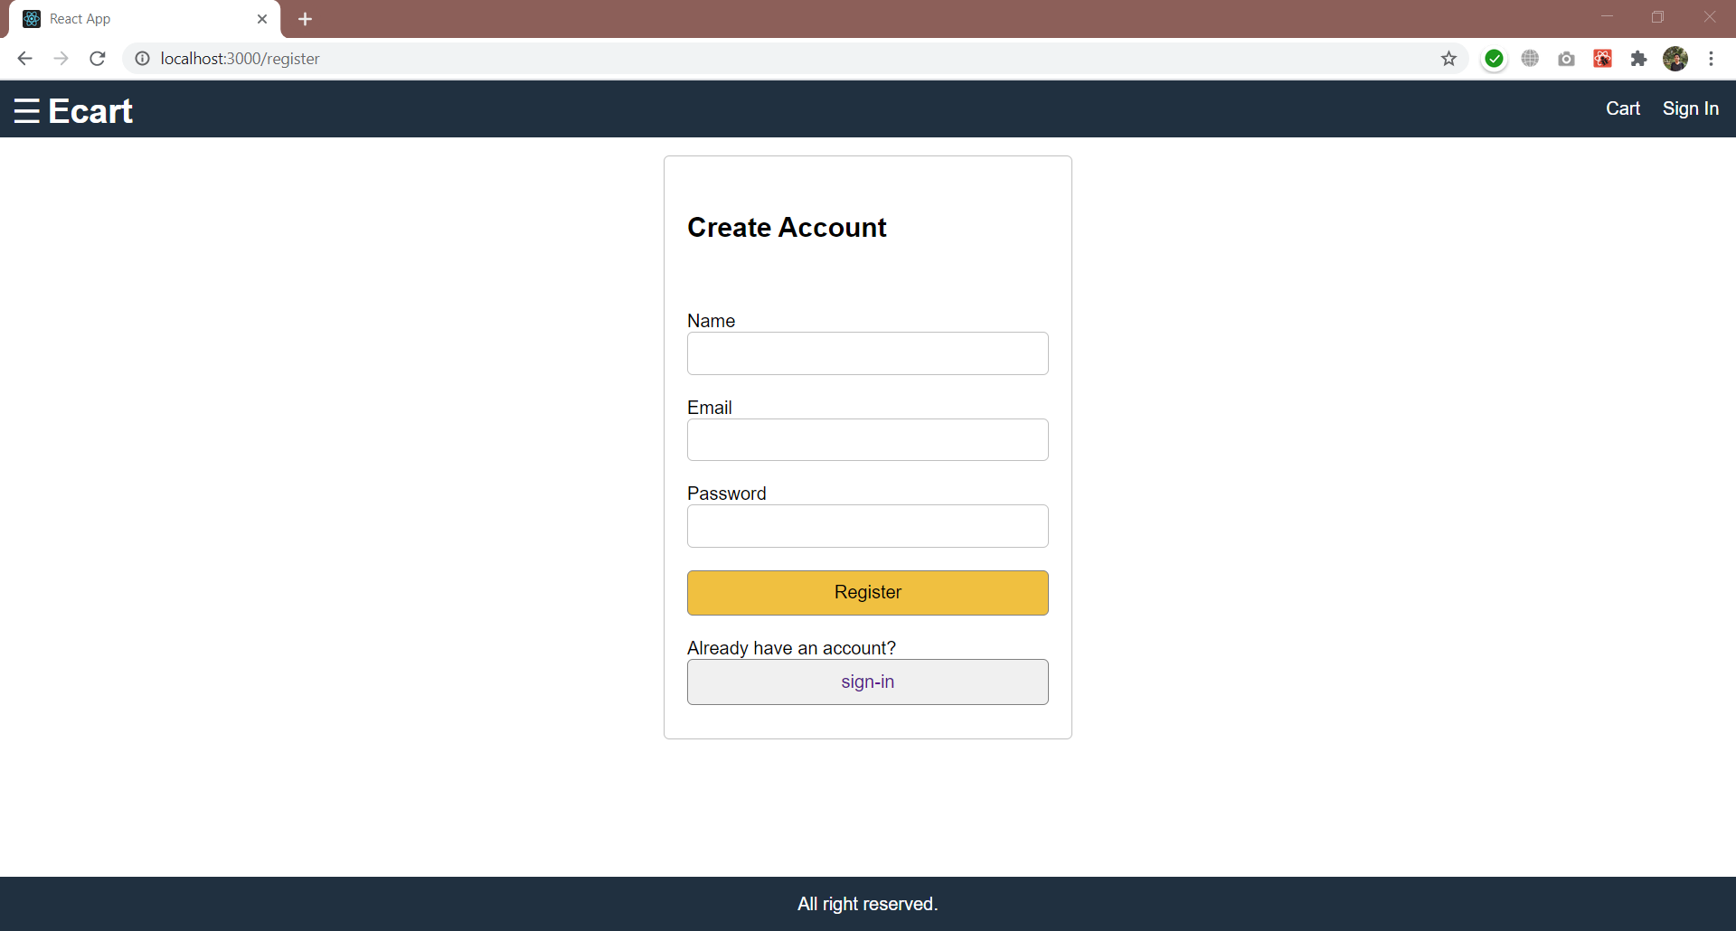

Fig.7.2: Registration Page

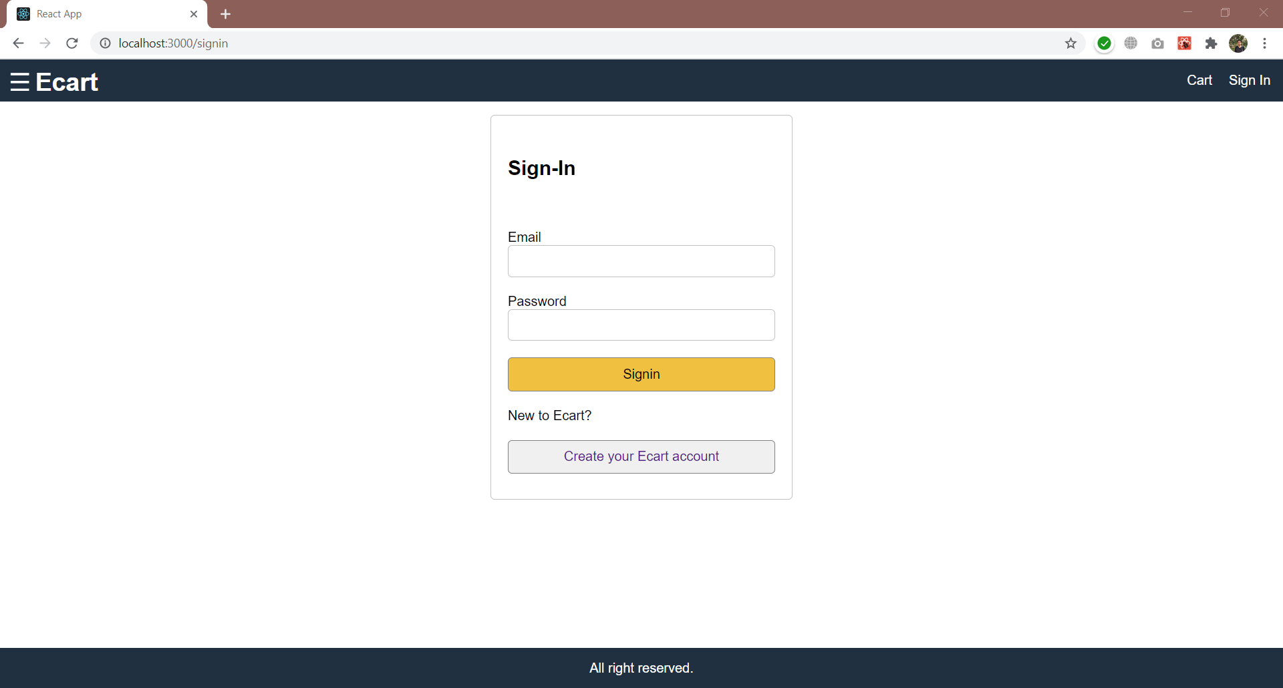

Fig.7.3: Sign-in Screen

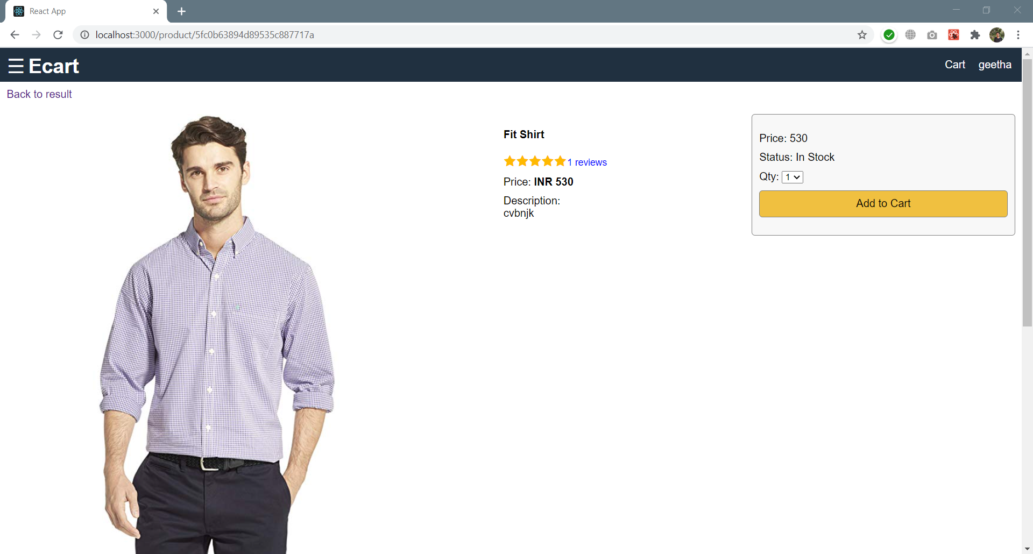

Fig.7.4: Product Screen

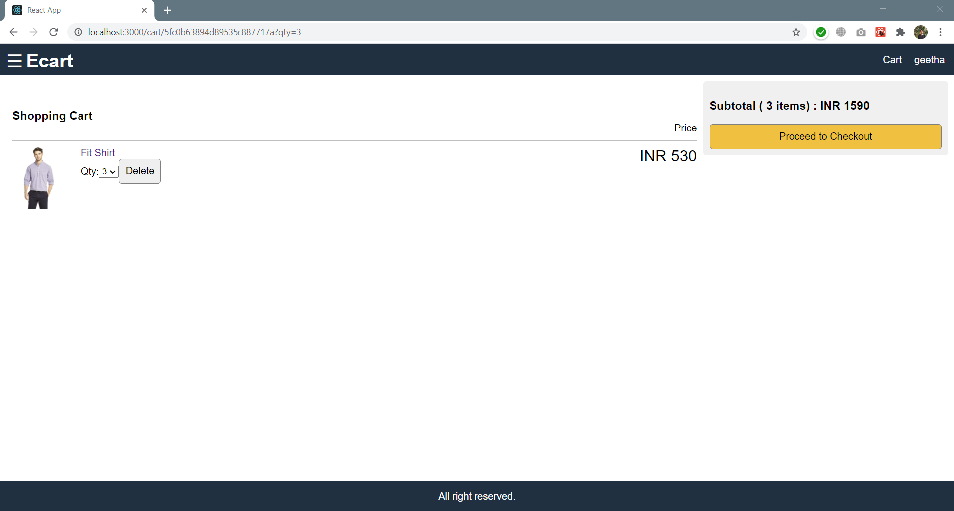

Fig.7.5: Cart Screen

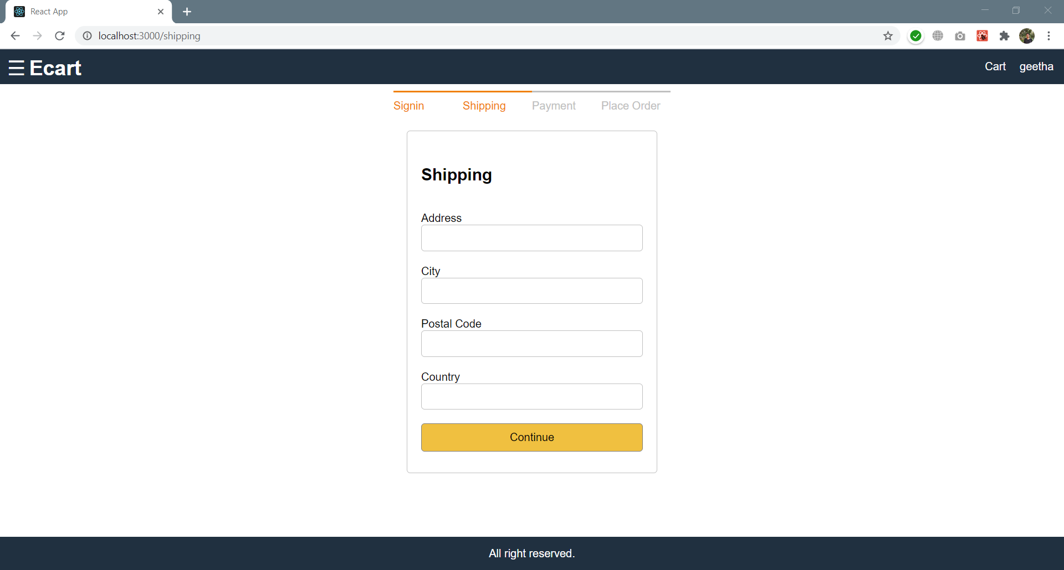

Fig.7.6: Shipping Screen

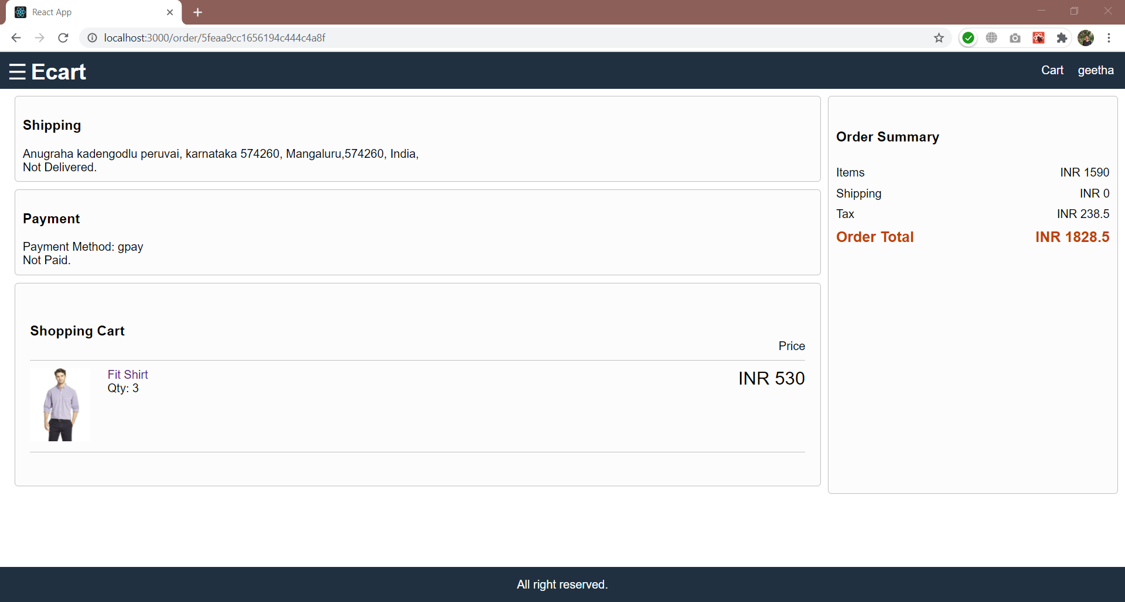

Fig.7.7: Order Screen

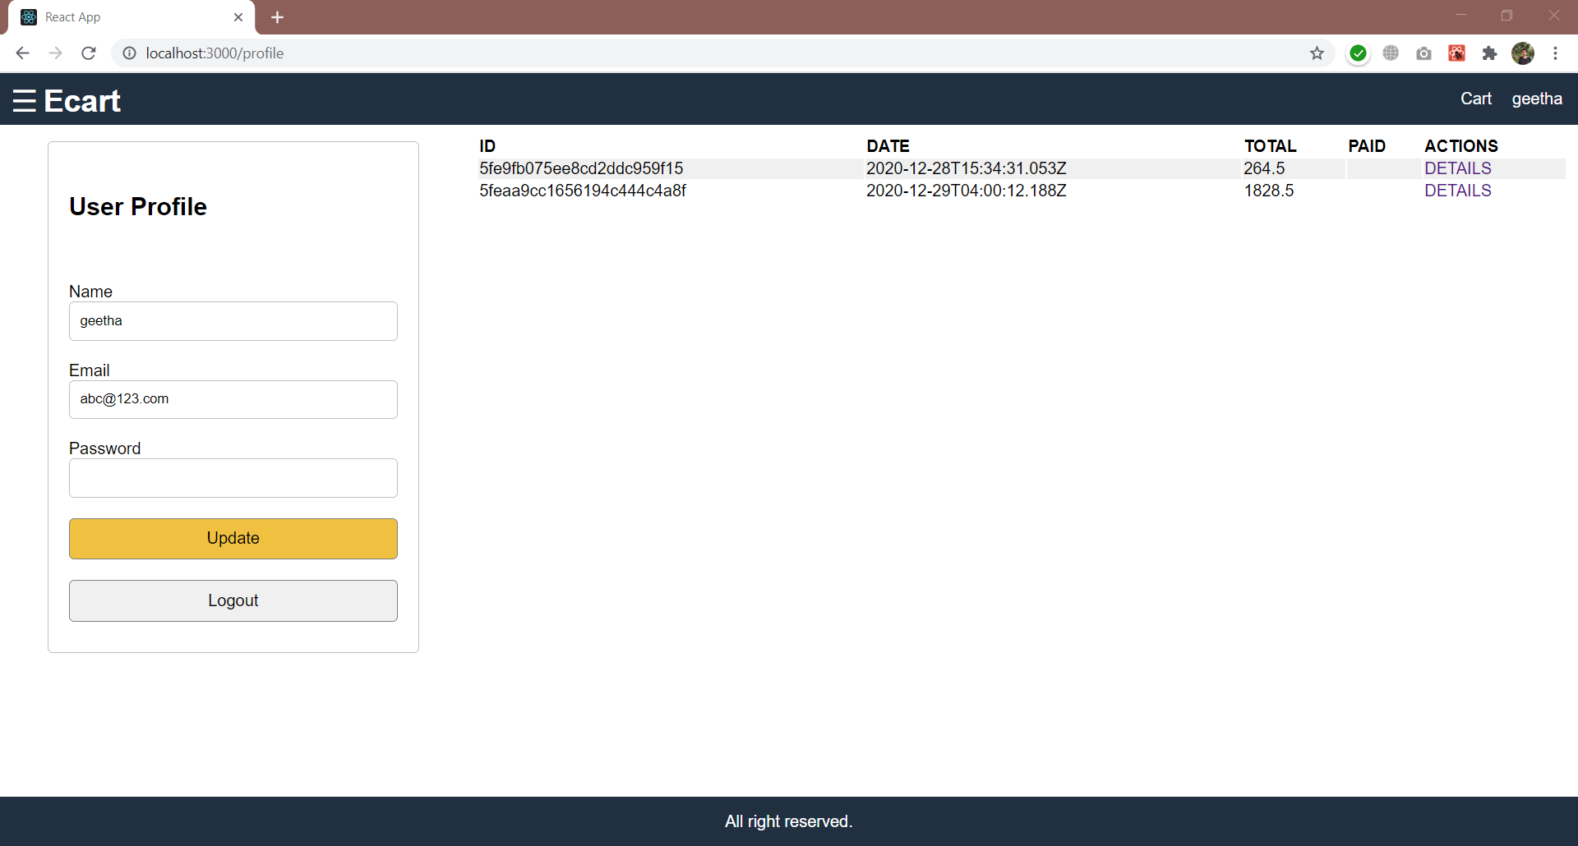

Fig.7.8: User Screen

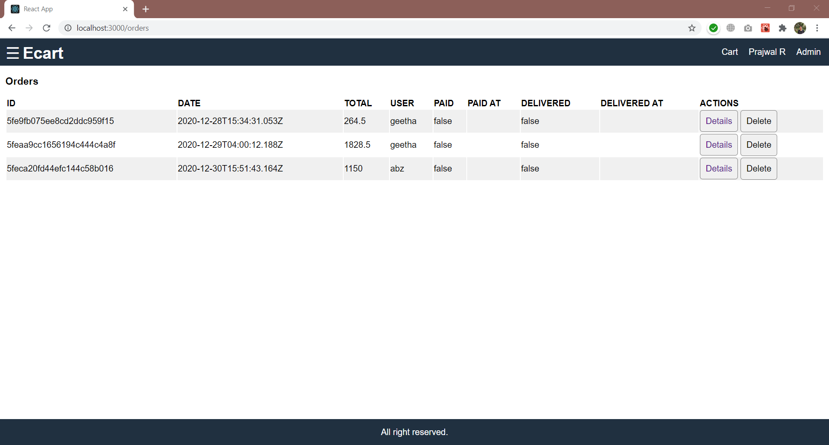

Fig.7.9: Admin monitoring order

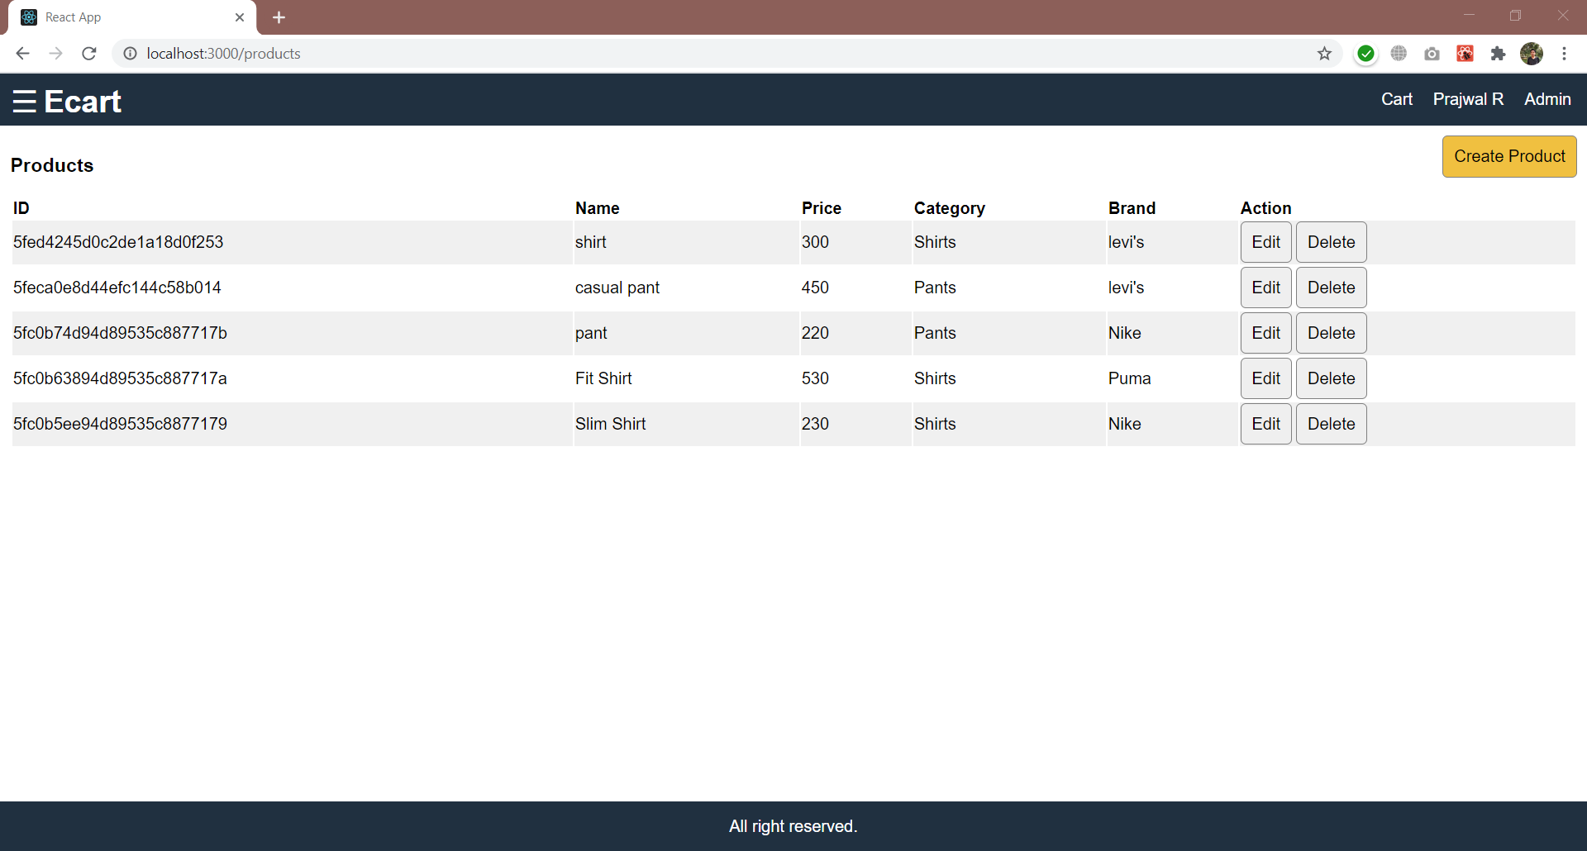

Fig.7.10: Admin monitoring product

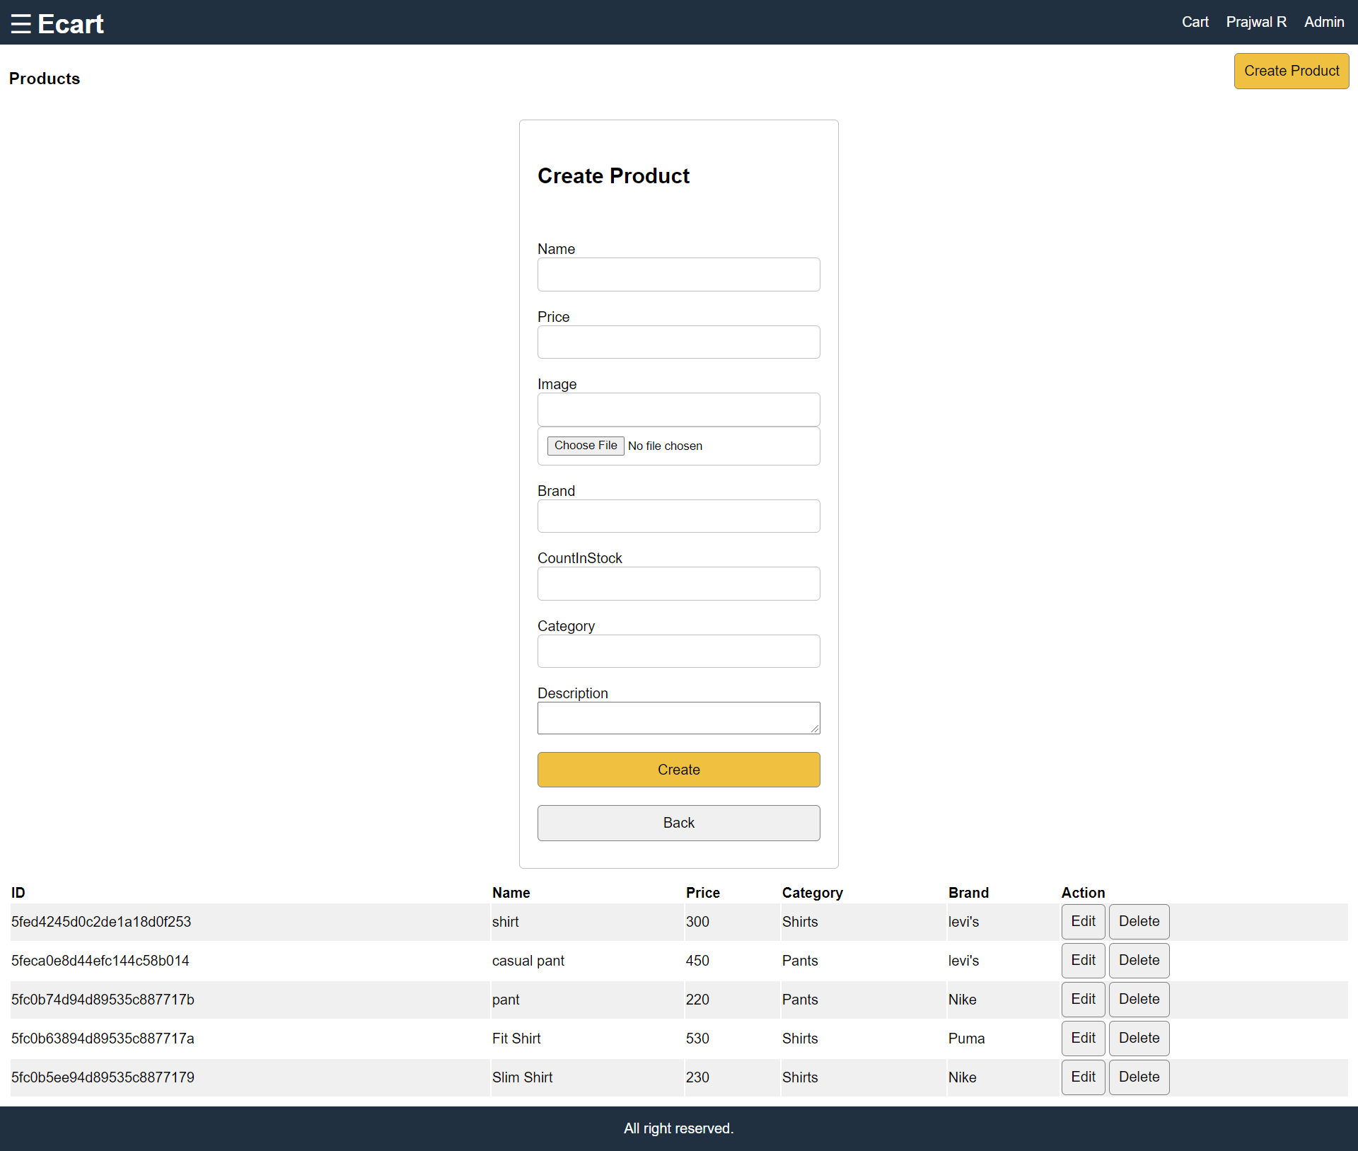

Fig.7.11: Create Product

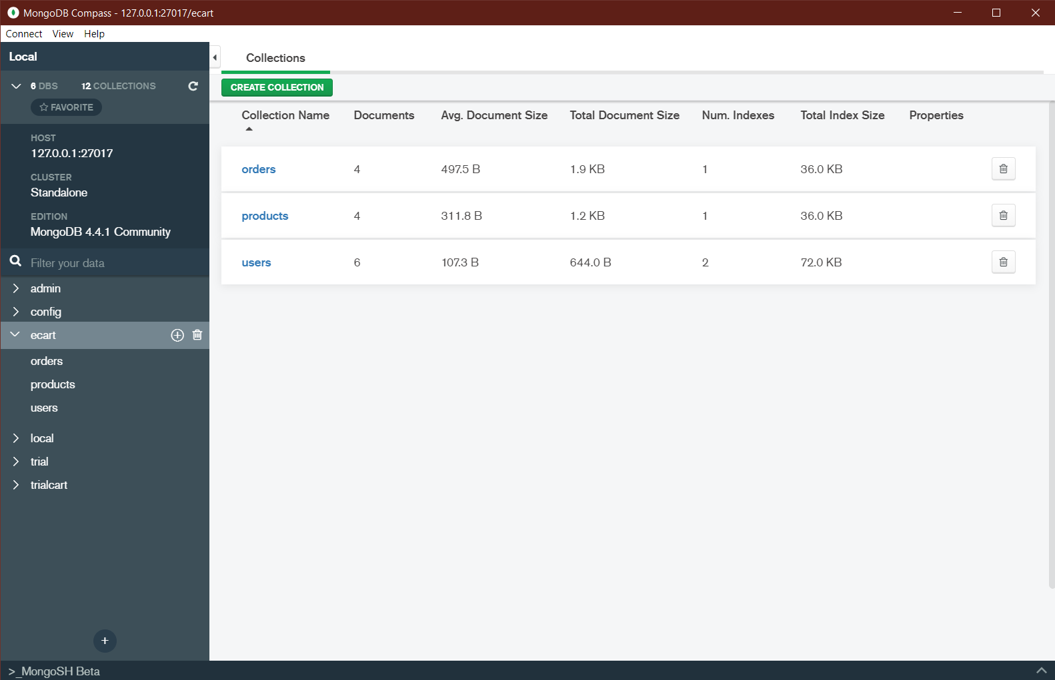

Fig.7.12: Database

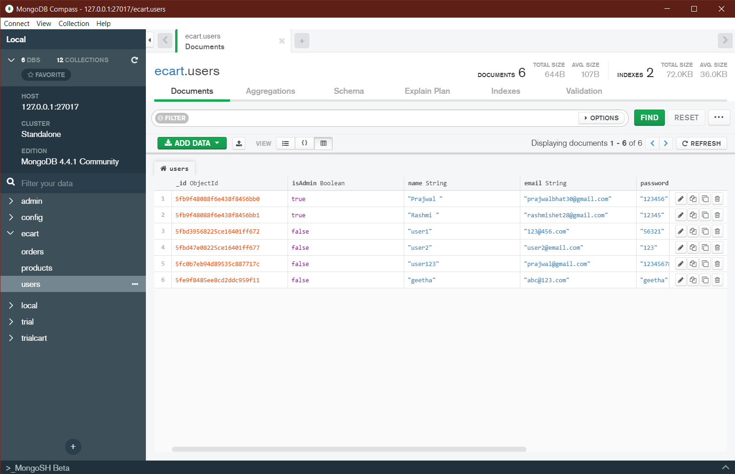

Fig.7.13. Users collection

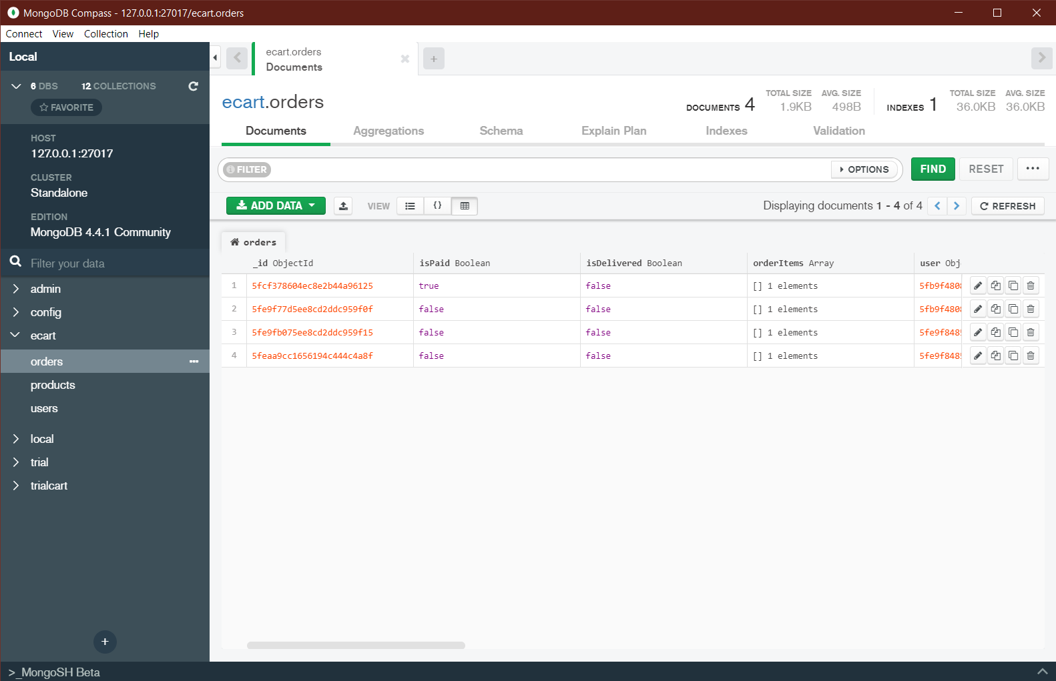

Fig.7.14: Orders collection

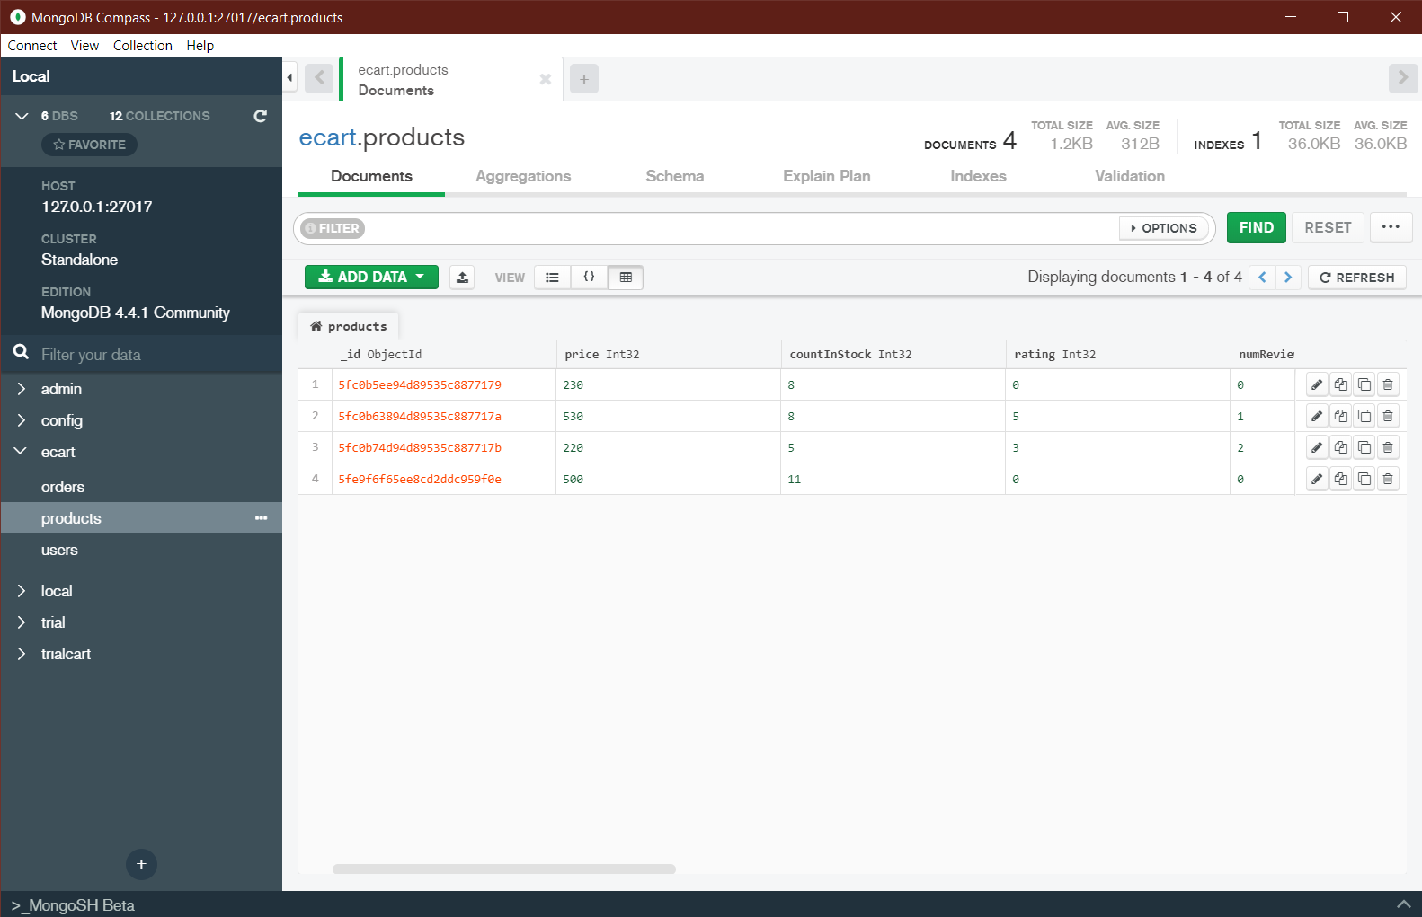

Fig.7.15: Products collection

**CONCLUSION**

In earlier times, people used to do manual shopping and now as time changes people are becoming busy and due to which technology has bought a new revolution i.e., online shopping. Day by day ecommerce site is getting lots of success.

In our project E-commerce site, we have stored the details of the products. Once the user is logged in, this database facilitates the user to view the categories, brand, price, and the status of no. of stocks. Also, he can buy his desired products online.

The technologies used HTML and CSS to design a user-friendly graphical user interface, Java Script, and NOSQL to keep track of the records at the back end. This system would be suitable for any e-commerce activity and thus lead to a qualitative and quantitative development of the individual.

**REFERENCES**

* React js : <https://reactjs.org/tutorial/tutorial.html>
* Node js : <https://www.w3schools.com/nodejs/>
* Mongo db : <https://docs.mongodb.com/manual/>
* IEEE : Yadong Huang;Yueting Chai;Yi Liu;Jianping Shen

Tsinghua Science and Technology Year: 2019

<https://ieeexplore.ieee.org/document/8526503>

* Youtube : <https://www.youtube.com/watch?v=Fy9SdZLBTOo&t=16686s>

<https://www.youtube.com/watch?v=RDV3Z1KCBvo>

# Department Vision & Mission



**Vision**

Emerge as Centre of learning in the field of information science & engineering with technical competency to serve the society.



**Mission**

To provide excellent learning environment through balanced curriculum, best teaching methods, innovation, mentoring and industry institute interaction.

**Programme Educational Objectives**



PEO-1: Successful professional career in Information Science & Technology.

PEO-2: Pursue higher studies & research for advancement of knowledge in IT industry.

PEO-3: Exhibit professionalism and team work with social concern.

**Programme Specific Outcomes**



1. Apply the knowledge of information technology to develop software solutions.
2. Design and Develop hardware systems, manage and monitor resources in the product lifecycle.

